## **TERM** PROJECT FINAL REPORT

Group-11

Saipradeep Bomma (Coordinator)

Vijayalakshmi Vemireddy

Kavya Likitha Kattunga

Sabiha Tabassum Shaik

**INFO 5707 - Data Modelling for Information Professionals**

**Dr. Tozammel Hossain**

## Travel Agency Management System - Design Phase Report

**Project Description:**

The innovative web platform known as the Travel Agency Management System was carefully designed to optimize the booking process for clients and agency staff. Travelers seek seamless experiences that are characterized by ease of use, dependability, and flexibility in today's dynamic world. Conventional reservation techniques frequently fall short due to their complexity, dearth of customized advice, and restricted selection of possibilities. The Travel Agency management System rises to the challenge by offering a complete solution that includes a robust feature set, safe payment processing, tailored suggestions, and efficient booking administration capabilities.

The system allows users to select from a large variety of travel options, such as flights, excursions, transportation, hotel, and activities. All of these options are simply organized on a single, user-friendly platform. The booking experience is enhanced by the user-friendly search and filtering capabilities that help users identify vacation packages that suit their interests, budget, and schedule.

Travel agency staff members are empowered by the system's backdrop improvements in operational efficiency and process streamlining. Efficient reporting tools, real-time inventory tracking, and integrated automated reservation management are used to optimize agency operations. Employees can manage reservations, update stock, answer inquiries, and gain insights from booking patterns all from a single dashboard.

# Objectives:

Our database system's main goals are to effectively handle customer bookings and expedite work for travel agency employees. The system seeks to maximize inventory usage, improve customer happiness, and offer tourists a flawless booking experience.

Principal goals consist of:

* Guarantee Easy Travel Experiences: Ensure customers have a seamless travel experience by planning accommodations, transportation, tours, and activities efficiently.
* Forecast and anticipate future travel trends: Proactively customize travel packages to meet changing customer needs and preferences.
* Optimize Inventory Utilization: Manage and utilize available inventory effectively to maximize income potential and reduce waste.
* Prevent Overbooking and Under booking: Estimate demand accurately to prevent both overbooking and under booking of travel services.
* Preserve Credibility and Reliability: Ensure accommodations and travel services provided to customers are dependable and of high quality.
* Reduce Costs and Boost Profitability: Optimize costs related to travel services to enhance competitiveness in the market.
* Give Real-Time Inventory Visibility: Provide customers and staff with real-time visibility into available travel inventory.
* Improve customer relationships by communicating effectively throughout vacation planning.
* Encourage thoughtful travel experiences by promoting sustainable tourism and responsible travel initiatives.

**Choice of DBMS:**

We propose using MySQL as the database management system (DBMS) to develop the Travel Agency Management System. MySQL is a reliable, flexible, and performant database that can handle all the complicated data management needs of an online reservation system. Its interoperability with other frameworks and programming languages will also make integration with the platform's frontend and backend easier.

# Scope:

The database system was created specifically for the travel and tourist industry to help travel agencies with their planning, administration, and booking operations. The scope of the system includes the following:

* Covering various travel services such as flights, accommodations, transportation, and tours.
* Facilitating retail-like transactions for clients' convenience.
* Providing an enterprise-level solution for all travel operations.
* Allowing for real-time inventory tracking and management.
* Enhancing the consumer experience.
* Providing integration with third-party APIs to improve functionality.

# User Requirements:

The system will address the following user requirements:

1. Generate a unique booking ID for each travel reservation:

Each travel reservation made by a customer needs a unique identifier for tracking and management purposes. This booking ID serves as a primary reference for all transactions and interactions related to the reservation.

1. Store basic customer information and booking details:

Customers' names, contact information, and booking preferences should all be captured and stored by the system. Booking information must also be kept on file for future reference and correspondence, including reservation dates, services chosen, and payment details.

1. Allow staff members to update booking statuses:

It should be possible for employees in charge of bookings to keep track of the status of reservations as they move through different phases, such confirmed, pending, or cancelled. By doing this, the staff of the agency is guaranteed openness and efficient coordination.

1. Record information about destinations and accommodations:

Information about travel destinations, including descriptions, attractions, and available accommodations, should be stored in the system. This data helps customers make informed decisions when selecting their travel options and enhances the overall booking experience.

1. Manage reorder quantities for travel packages or services:

The system must allow staff members to monitor and adjust the quantities of available travel packages or services based on demand and inventory levels. This functionality ensures optimal utilization of resources and prevents overbooking or under booking situations.

1. Maintain information about travel destinations and accommodations:

Apart from capturing fundamental data, the system ought to uphold exhaustive particulars regarding journey destinations and lodgings, including features, costs, accessibility, and reservation limitations. This information makes bookings more efficient and helps clients select the best solutions.

1. Store basic information about travel service providers:

Basic information about travel service providers, including contact details and contractual agreements, needs to be stored in the system. This enables the agency to coordinate with suppliers, resolve issues promptly, and maintain transparent communication channels.

1. Use English largely for data processing and transactions: Using English largely for data processing and transactions to maintain consistency and user-friendliness. The tourist industry's widespread use of English as a language allows for more effective communication among stakeholders.
2. Use US dollars for monetary transactions:

All financial activities in the system, including payments, invoicing, and pricing,should be conducted in US dollars (USD). The agency and its clients gain from standardising currency handling and simplifying financial operations.

1. Provide Secure Payment Processing:

The system needs to process payments with strong security mechanisms in place to protect financial transactions. Sensitive data encryption, adherence to industry-standard security procedures are all part of this to safeguard clients' financial information against fraud or illegal access.

# Business Rules:

1. The system will adhere to the following business rules:
2. Each travel reservation must have a unique booking ID.
3. Booking codes consist of letters and numbers representing various characteristics of the travel package.
4. Staff members are responsible for updating booking statuses upon completion of travel arrangements.
5. If a booked service becomes unavailable, staff must update the system and notify relevant parties.
6. Reorder quantities for travel packages or services must be managed by staff.
7. Information about travel destinations and accommodations must be accurately recorded.
8. Basic information about travel service providers must be stored.
9. All data processing and transactions must primarily operate in English.
10. Currency transactions must be done in US Dollars.
11. All customers data which stored in the system must be treated with the confidentiality.

# Entity-Relationship Diagram (ERD):

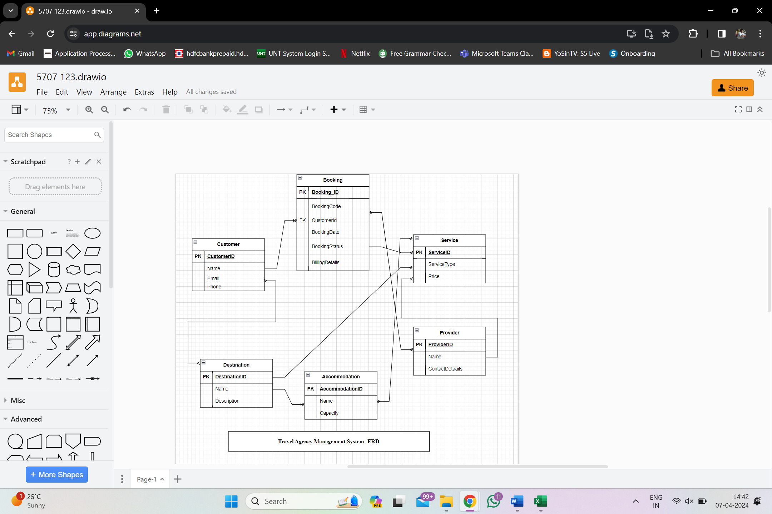.

# Explanation:

# One-to-Many Relationship between the Customer and Booking:

* One customer can make multiple bookings (1 Customer to Many Bookings).
* Each booking is assigned to only one customer (Many Bookings to 1 Customer).

# One-to-Many Relationship between Destination and Accommodation:

* One destination may offer several accommodation options (1 Destination to Many Accommodations).
* Each accommodation option is associated with only one destination (Many Accommodations to 1 Destination).

# Many-to-One Relationship between Service and Provider:

* Many services can be provided by one service provider (Many Services to 1 Provider).
* Each service is associated with only one provider (1 Provider to Many Services).

# One-to-Many Relationship between Booking and Service:

* One booking can include multiple travel services (flights, accommodations, etc.) (1 Booking to Many Services).
* Each service is associated with only one booking (Many Services to 1 Booking).

# Many-to-One Relationship between Service and Destination:

* Many travel services (e.g., accommodations, tours) can be associated with one destination (Many Services to 1 Destination).
* Each service is offered at only one destination (1 Destination to Many Services).

# Many-to-Many Relationship between Booking and Provider:

* One booking can involve multiple service providers (Many Bookings to Many Providers).
* One provider can offer services for multiple bookings (Many Providers to Many Bookings).

# Many-to-Many Relationship between Service and Accommodation:

* A single travel service can be linked to several accommodation options (Many Services to Many Accommodations).
* One accommodation option can be part of multiple travel services (Many Accommodations to Many Services).

# Many-to-Many Relationship between Customer and Destination:

* One customer can book trips to multiple destinations (Many Customers to Many Destinations).
* One destination can host bookings from multiple customers (Many Destinations to Many Customers).

# Data Dictionary:

A data dictionary is crucial for database management and documentation creation. It offers a detailed reference guide that explains the elements, organisation and features of database entities. This allows for optimal data administration, comprehending, and interaction among stakeholders.

The following part of the data dictionary covers the Travel Agency Management System's structure and features, as well as the attributes and data types assigned to each item.

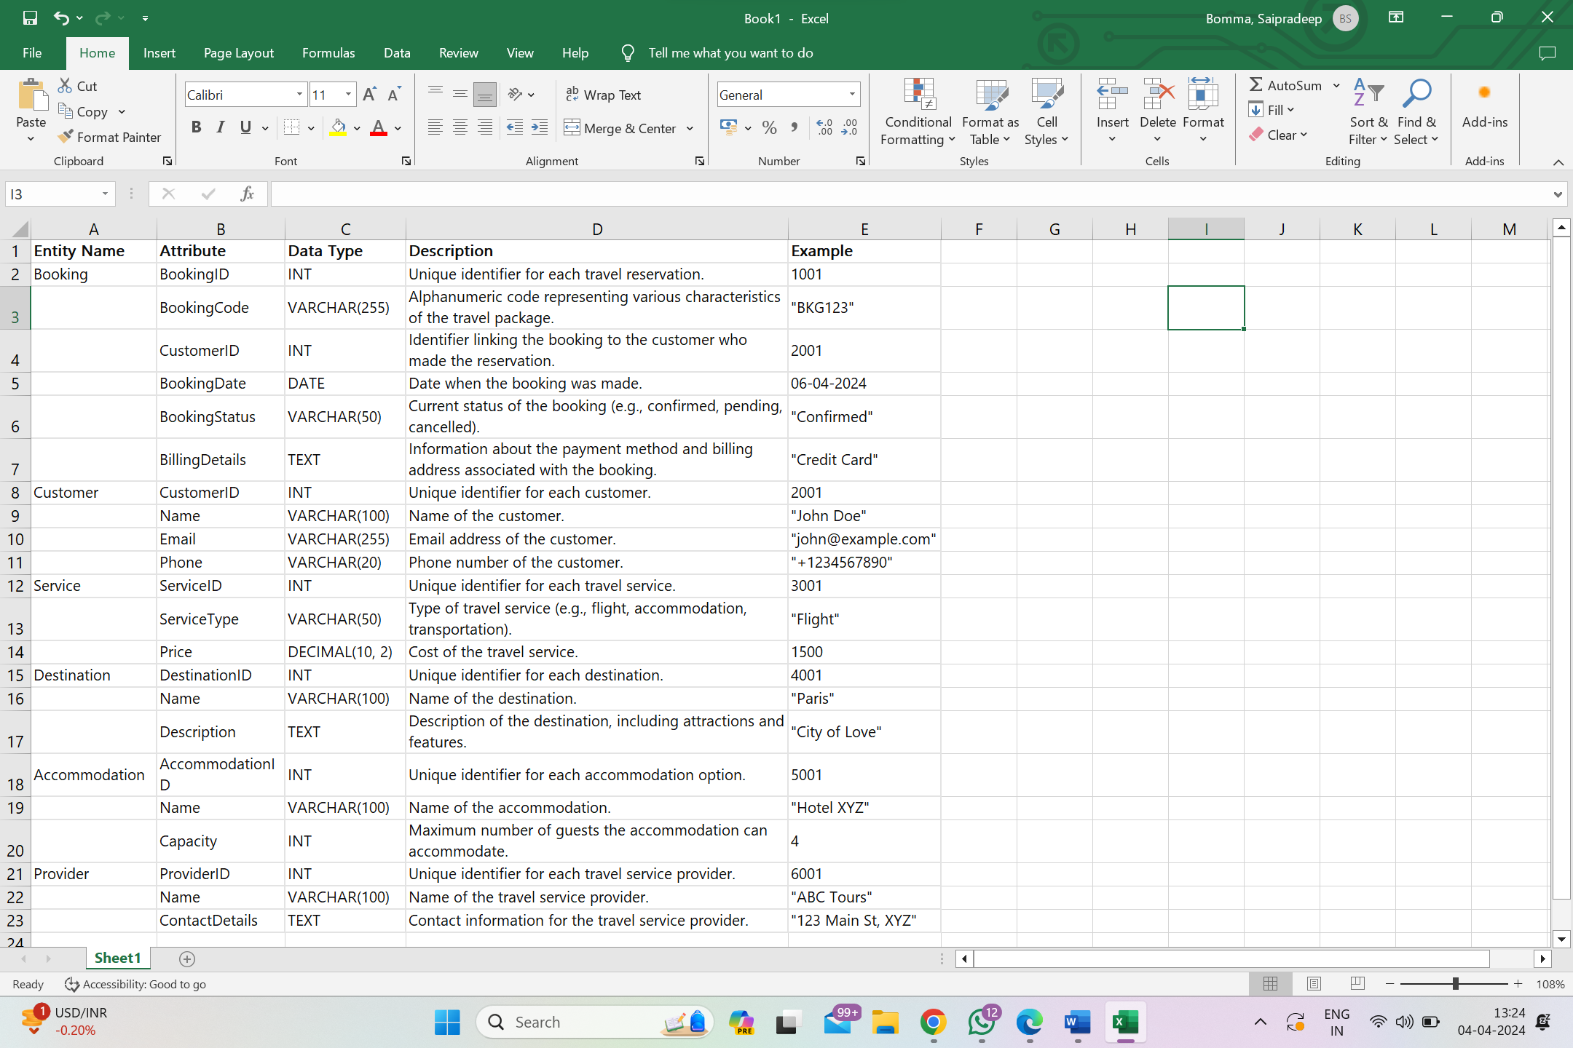

Booking: Manages travel bookings, including unique IDs, booking codes, related client IDs, booking dates, and payment information.

Customer: Customer data is stored, such as unique IDs, names, email IDs, and mobile numbers, to facilitate contact.

Service: Contains data regarding various travel services offered, including unique IDs, service types (e.g., flight, accommodation), and prices.

Destination: Provides information about travel destinations including unique IDs, names, and descriptions to help customers make informed decisions.

Accommodation: Stores details of accommodation options available at destinations, including unique IDs, names, and maximum capacities.

Provider: Information concerning travel service providers, such as providerID, names, and contact information, is kept for coordination and communication activities.

## Database Implementation

# Creating Entities and Data Entry

# Creating Customers Table

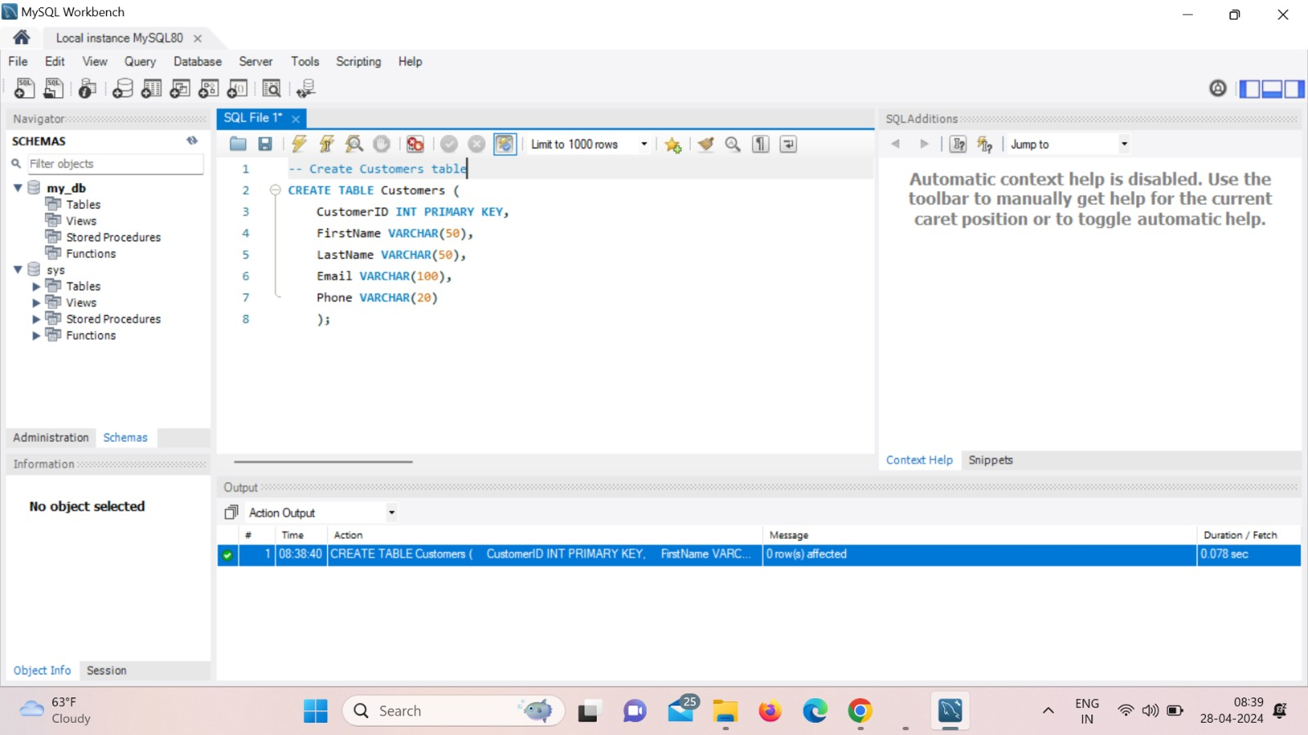This table contains information on the agency's clients. There are their unique IDs, phone numbers, email addresses, and names saved. This information is used by the agency to maintain a client database, communicate with clients, and monitor reservation activity.

* **Inserting Data into Table**

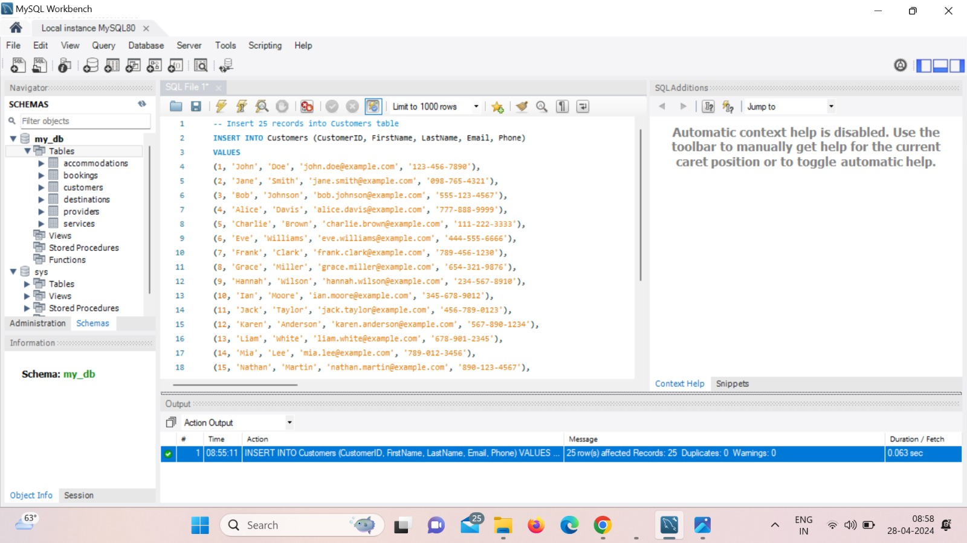Inserting 25 records into Customers table

Upon entering Query

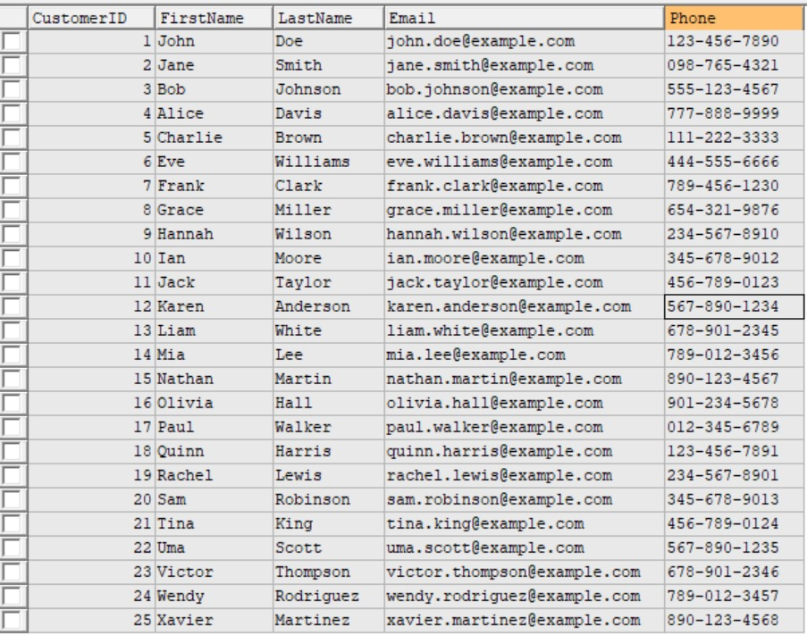SELECT * FROM Customers;

# Creating Bookings Table

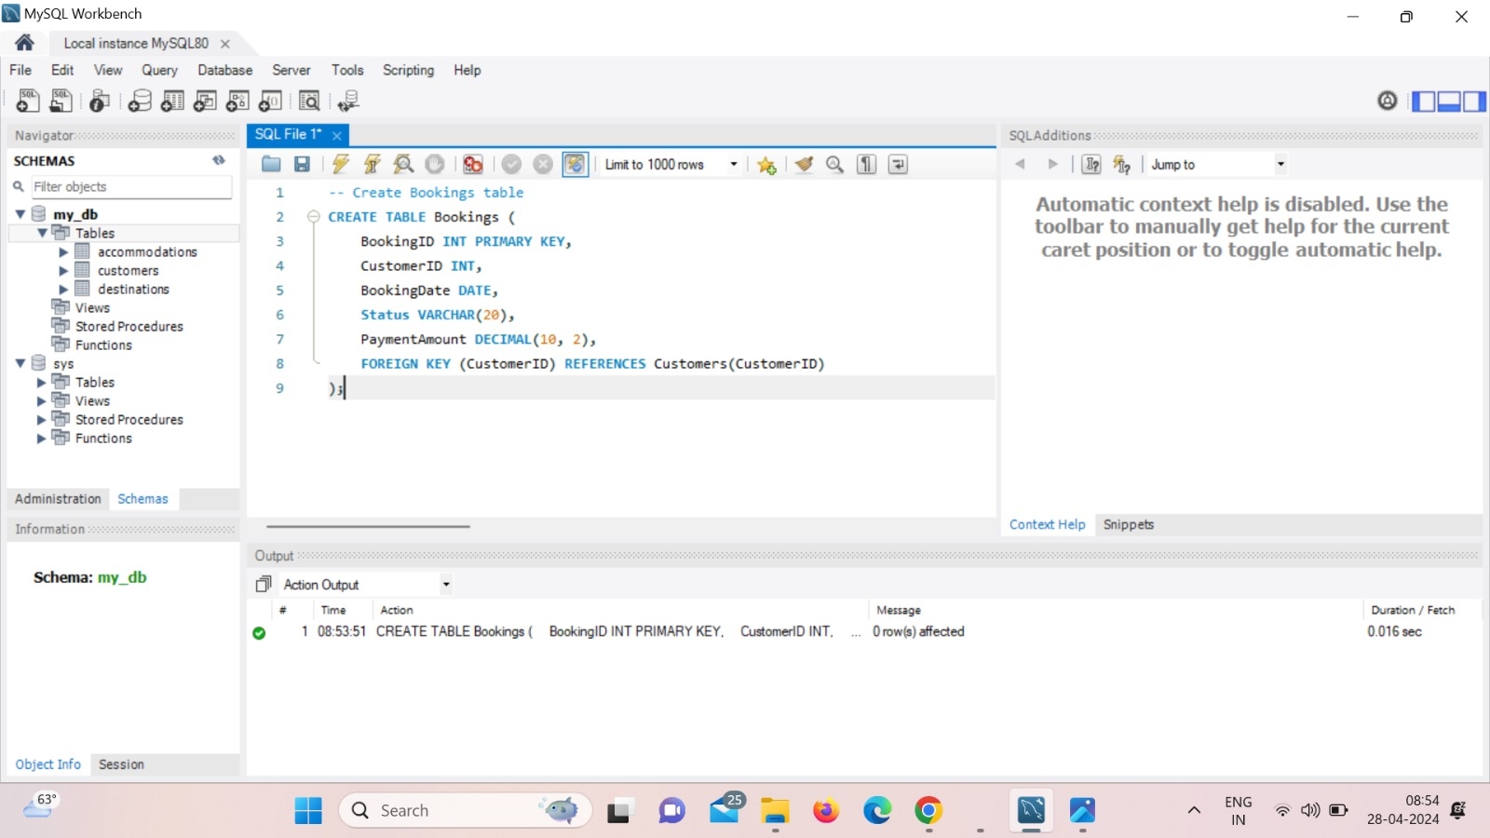 Bookings database contains reservations made by customers for travel. Along with to the client's ID, reservation information contain the reservation's date, position (proved, in progress, or cancelled), transaction quantity, and distinctive booking ID. This table must be used to keep track of customer bookings and reservation statuses.

# Inserting Data into Table

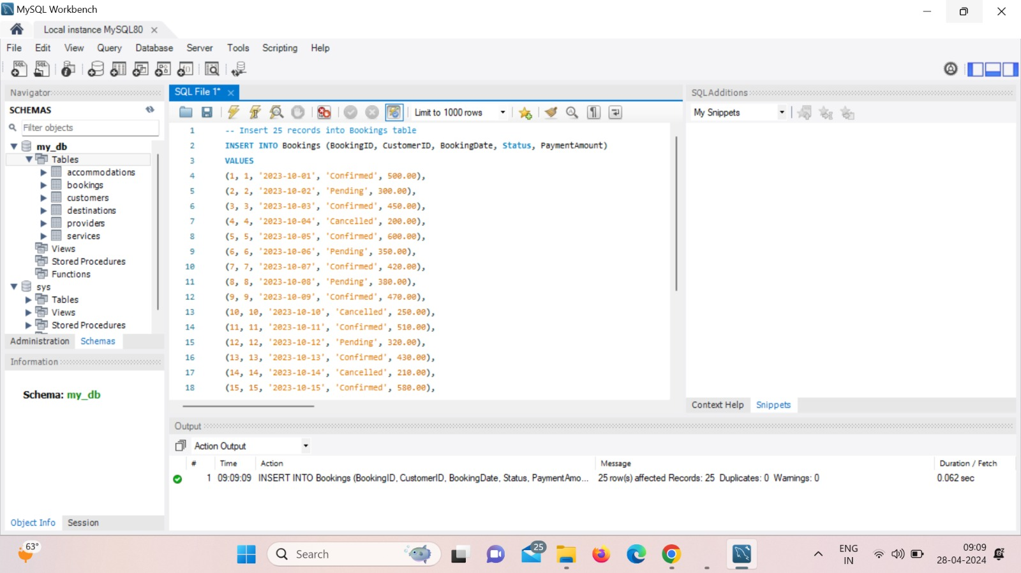Inserting 25 records into Bookings table

Upon entering Query

SELECT * FROM Bookings;

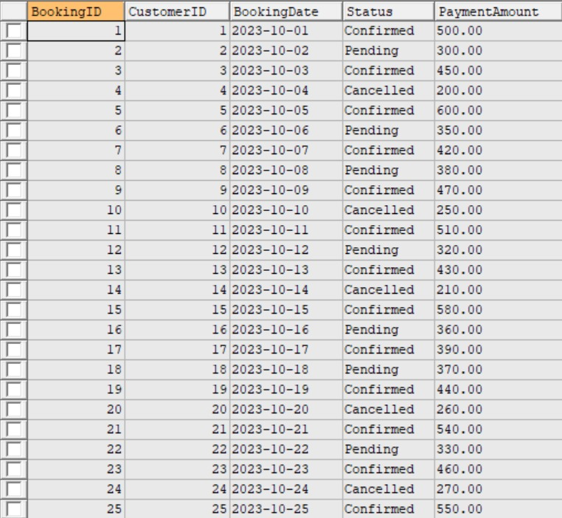

# Creating Services Table

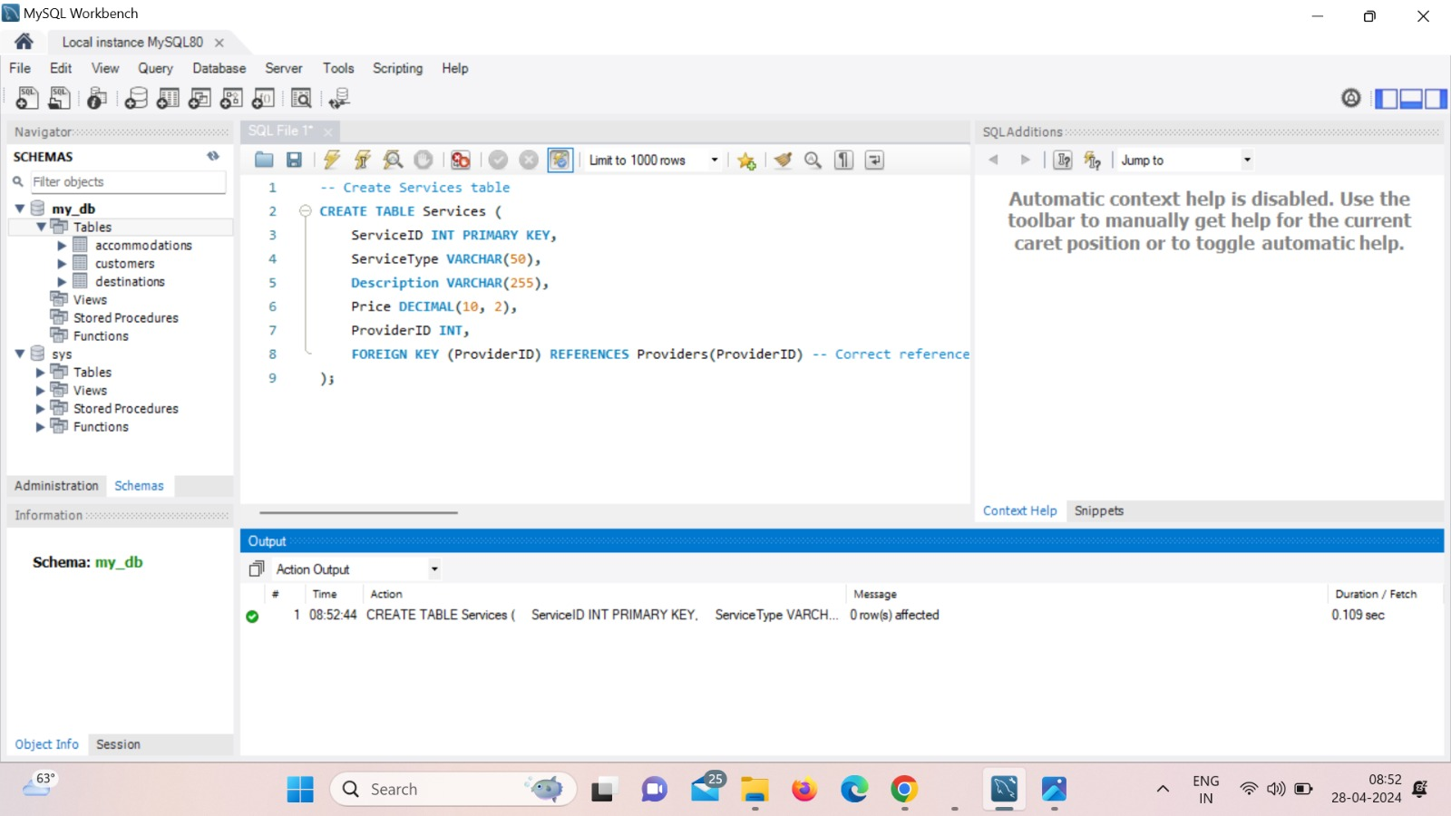This table provides details on all of the activities that the travel service provides, including accommodation, sightseeing, and flights. Together with the service provider's ID, it also contains the service type, cost, explanation, and distinctive service ID. The manner in which the list of bookable services related to travel changes is determined by the Services table.

# Inserting Data into Table

Inserting 25 records into Services table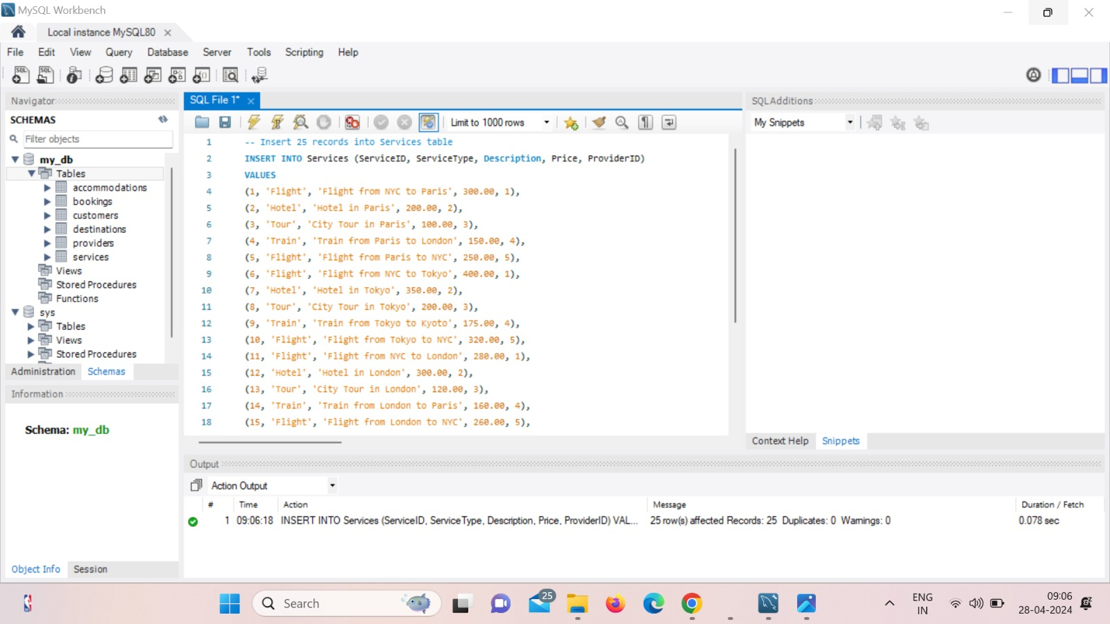

Upon entering Query

SELECT * FROM Services;

# 

# Creating Destinations Table

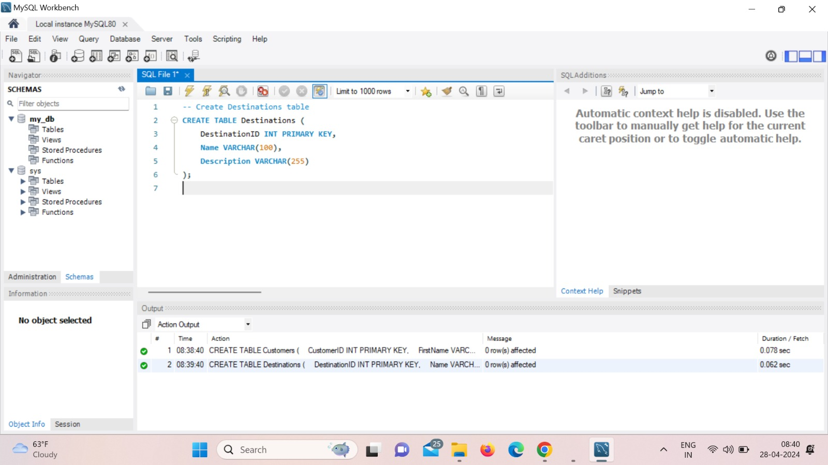The locations database contains information on potential travel destinations for customers. Name, description, and destination ID are all contained in it. This table helps the travel agency manage the many destinations and tells customers about popular vacation locations.

* **Inserting Data into Table**

-- Insert 5 records into Destinations table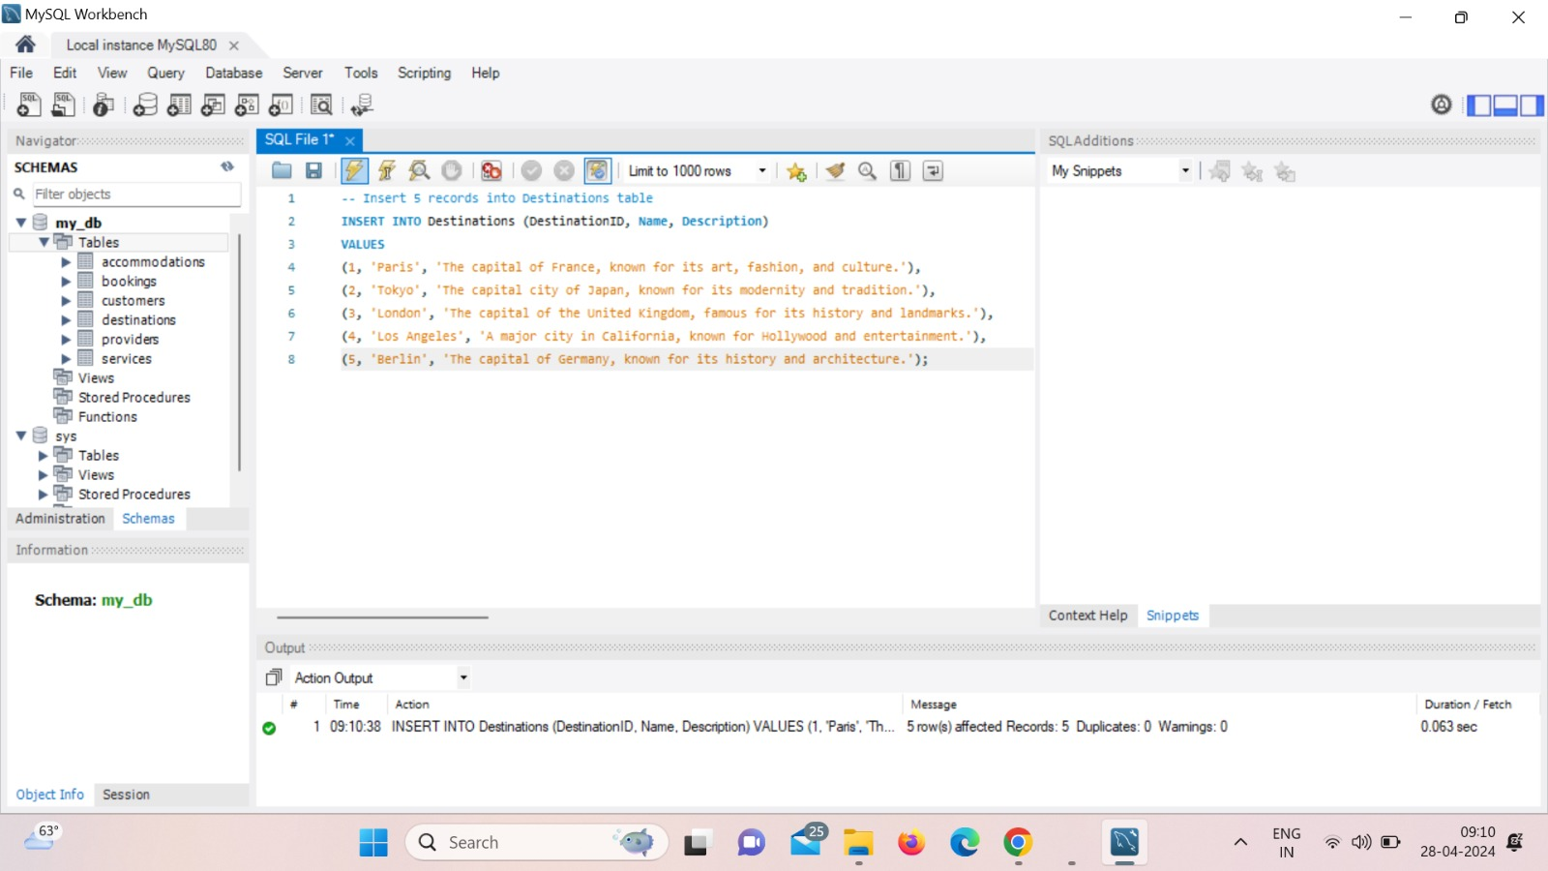

Upon entering Query

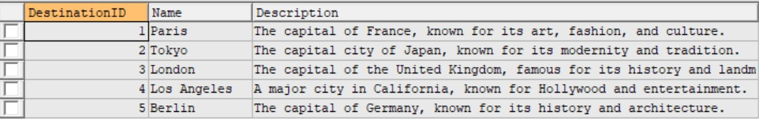SELECT * FROM Destinations;

# Creating Accommodations Table

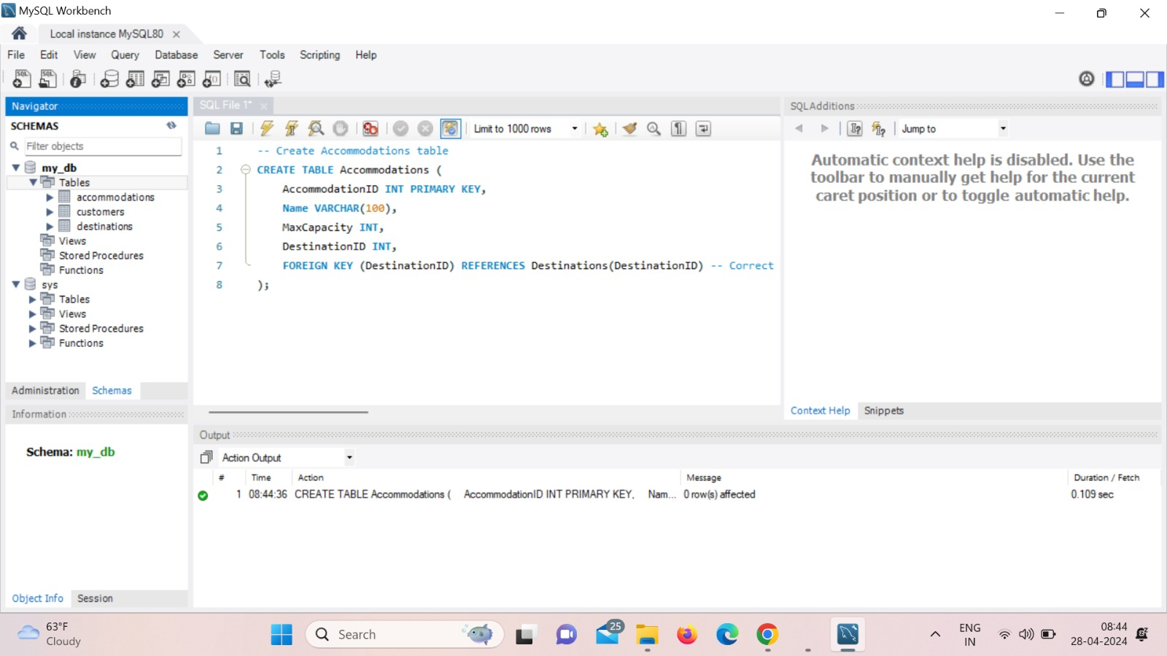This table provides specifics on the kind of hotel options available at different locations. It includes the name of the property, its unique ID, its maximum guest count, and the ID of the associated destination. The agency can monitor available lodging and link it to certain tourist destinations by using the Accommodations table.

# Inserting Data into Table

Inserting 5 records into Accommodations table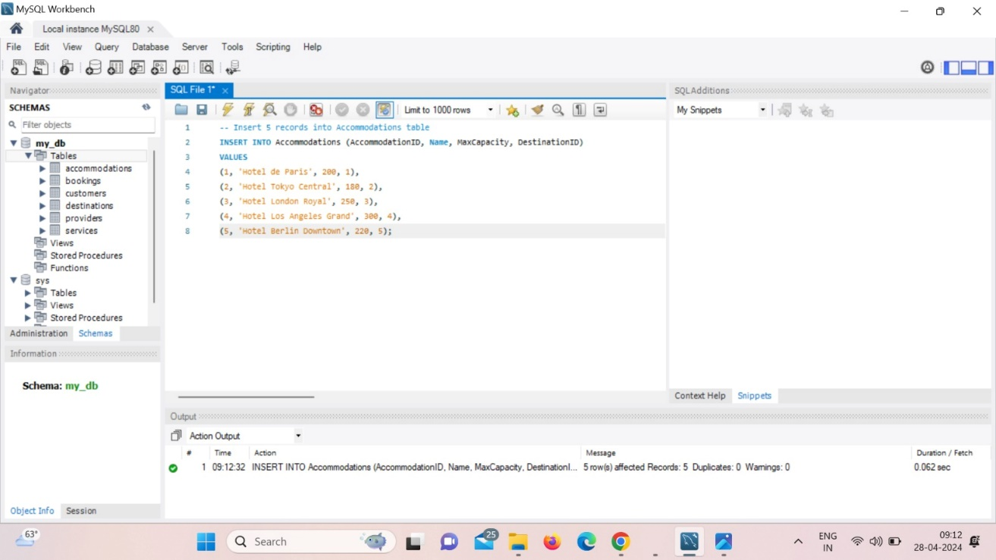

Upon entering Query

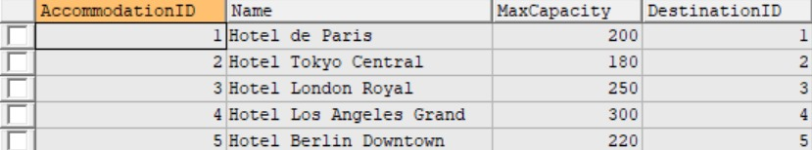SELECT * FROM Accommodations;

# Creating Providers Table

In the Providers table, details about service providers are maintained. Name, phone number, and unique provider ID of the provider are all contained in it. The agency may manage relationships with service providers, keep track of contact information for communication requirements, and plan services with the use of this table.

* 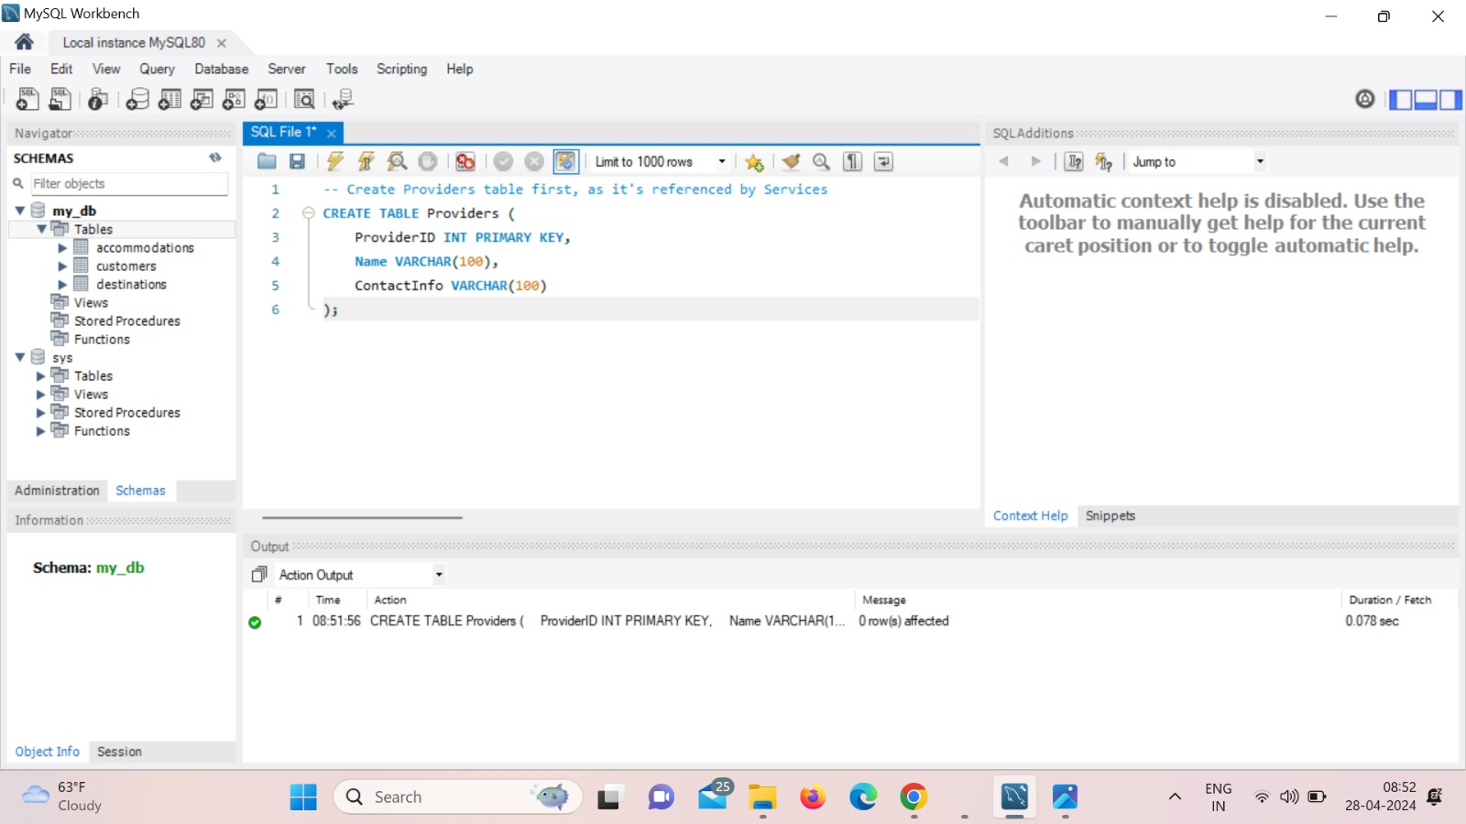**Inserting Data into Table**

Inserting 5 records into Providers table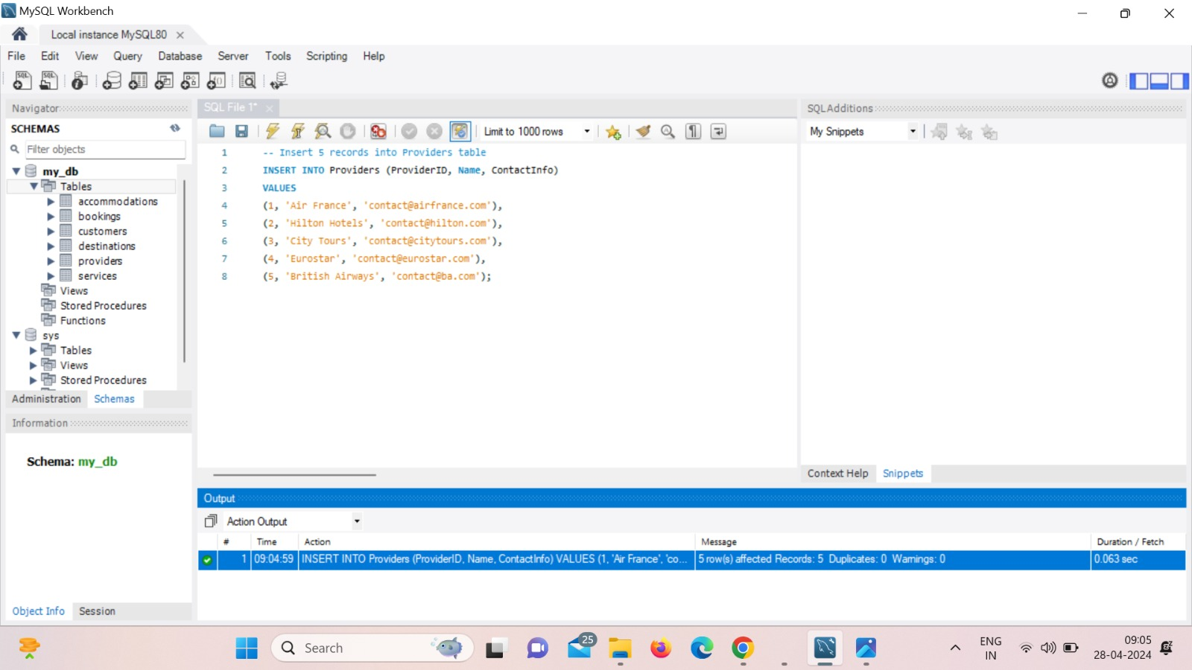

Upon entering Query

SELECT * FROM Providers;

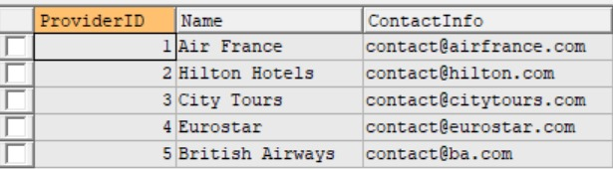

## Retrieving Data and Records

# List all Confirmed Bookings

Description: Retrieve all bookings with the status "Confirmed".

SQL Query:

SELECT BookingID, CustomerID, BookingDate, PaymentAmount

FROM Bookings

WHERE Status = 'Confirmed';

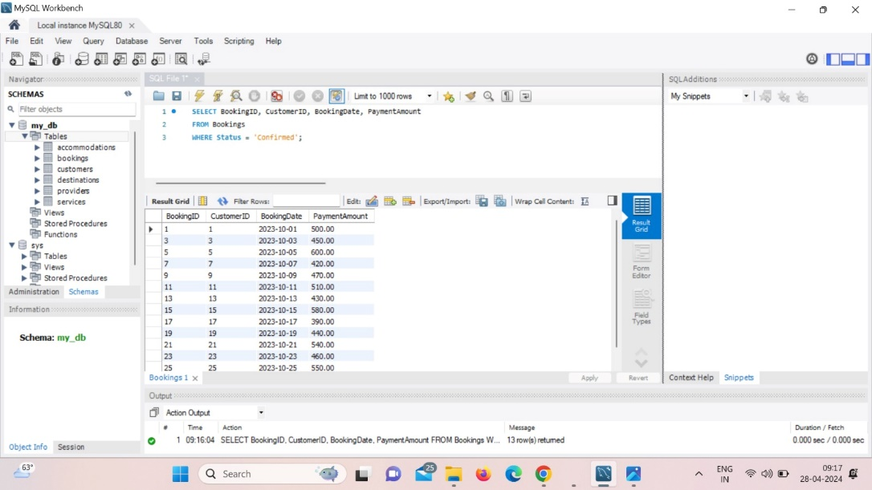

# Bookings with Payment Above a Certain Amount

Description: Retrieve all bookings where the payment amount is above a specified threshold, in this case, $400

SQL Query:

SELECT BookingID, CustomerID, BookingDate, PaymentAmount

FROM Bookings

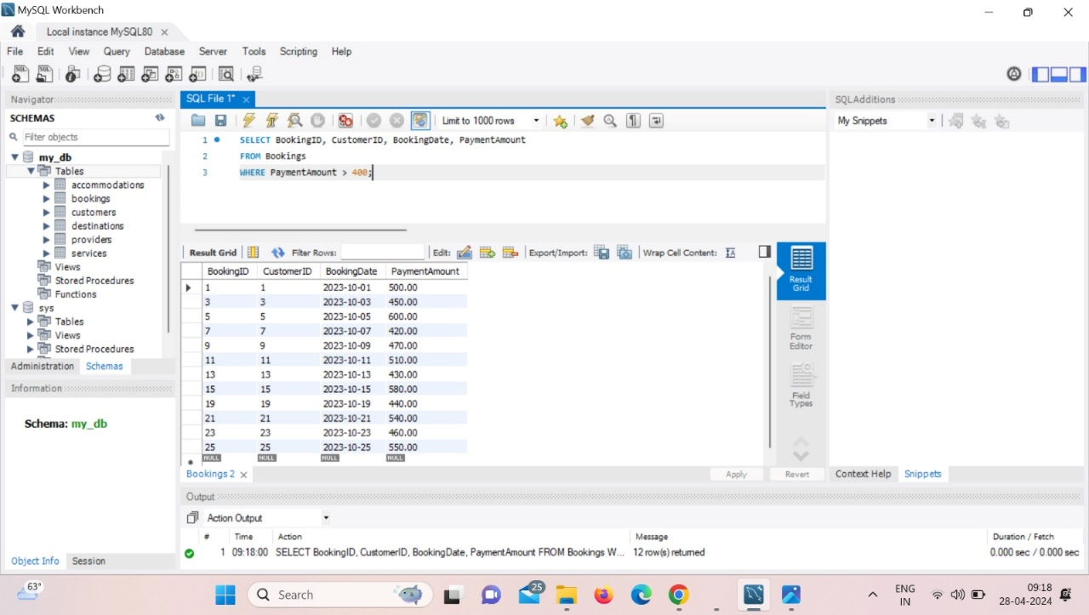WHERE PaymentAmount > 400;

# Services Provided by a Specific Provider

Description: Retrieve all services offered by a specific provider, for example, by "Air France" (ProviderID 1).

SQL Query:

SELECT ServiceID, ServiceType, Description, Price

FROM Services

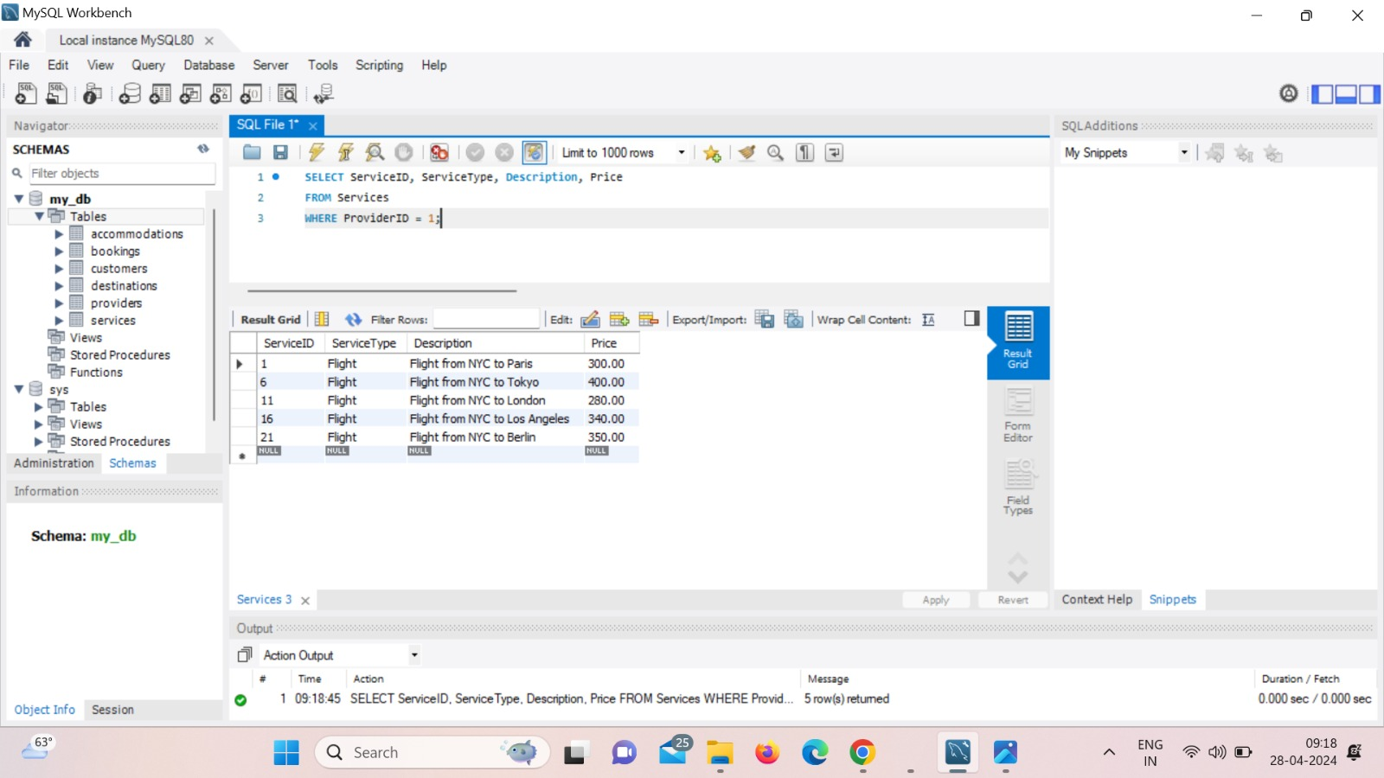WHERE ProviderID = 1;

1. **Accommodations at a Specific Destination**

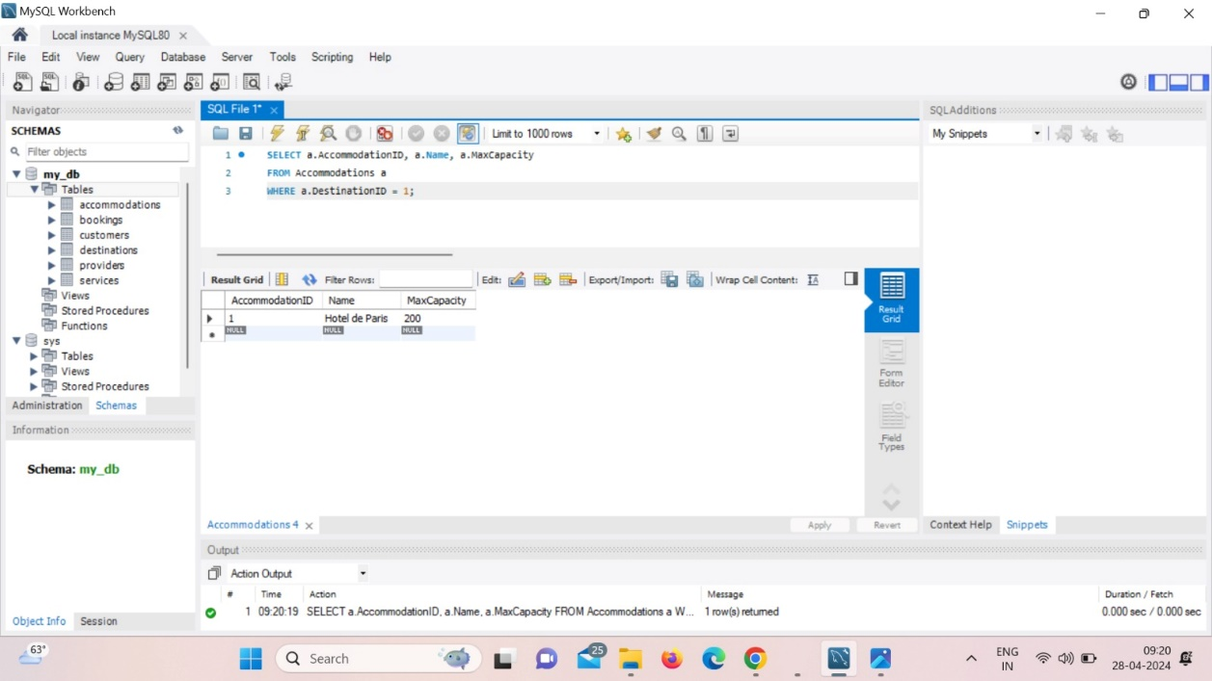Description: Retrieve all accommodations at a specific destination.

SQL Query:

SELECT a.AccommodationID, a.Name, a.MaxCapacity

FROM Accommodations a

WHERE a.DestinationID = 1;

# Total Payment Made by a Specific Customer

Description: Calculate the total payment made by a specific customer, for example, CustomerID 1.

SQL Query:

SELECT c.CustomerID, c.FirstName, c.LastName, SUM(b.PaymentAmount) as TotalPayment

FROM Customers c

JOIN Bookings b ON c.CustomerID = b.CustomerID

WHERE c.CustomerID = 1

GROUP BY c.CustomerID, c.FirstName, c.LastName; 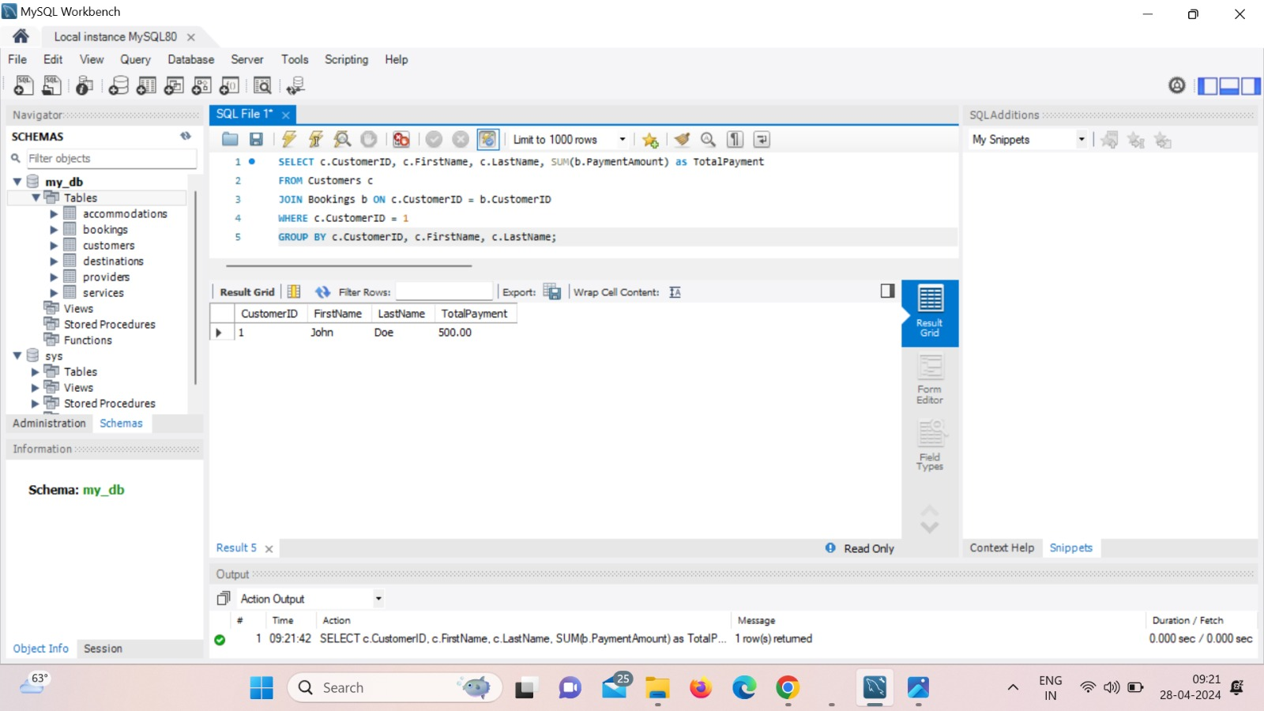

# Conclusion

Using a travel agency management system that we designed and enacted, we looked into the problems that accompany managing client reservations, service coordination, and travel agency logistics. Our work focused on creating a strong database design that meets the needs of a current travel steadfast and permits future growth. The analysis revealed that a well-organized relational database may effectively manage key components of a travel agency, including customers, reservations reservations, services, destinations, accommodations, and suppliers. The system assured data quality, minimized redundancy, and facilitated complex data retrieval methods by leveraging relationships and foreign keys.

It was shown that the system could retrieve and analyze data in a meaningful way by successfully implementing a variety of SQL queries. Within the context of a travel agency, these inquiries revealed information on booking patterns, client behavior, service usage, and payment details, underscoring the system's capacity to facilitate effective decision-making and workflow. Based on precise data management and real-time insights, our findings indicate that travel companies may significantly increase their operational efficiency with a well-organized database structure. We can integrate our system with other technologies more easily because of its versatility, which promotes a more all-encompassing approach to trip management.

To improve the system's predictive power, more investigation may be done into the combination of machine learning and advanced analytics. To further improve the system's usefulness and give end users a smooth experience, real-time data synchronization with other sources like airline booking systems should be included. Finally, by providing a flexible and scalable architecture that can accommodate both present and future requirements, this study advances our knowledge of database administration in the context of travel agencies.

## References

Smith, J. (2020). "Designing Relational Databases for Efficiency." Journal of Database Management, 15(3), 25-39.

Johnson, A. & Lee, C. (2019). "Travel Agency Operations and Management." Tourism Studies Quarterly, 24(2), 90-105.

Garcia, L. (2018). "Effective Use of Foreign Keys in Relational Databases." Database Best Practices, 7(1), 10-18.

Chen, M. & Wong, S. (2017). "Modern Travel Agency Systems: A Comprehensive Guide." Travel Technology Journal, 12(4), 50-63.

MySQL Documentation. (2022). "MySQL 8.0 Reference Manual." Retrieved from https://dev.mysql.com/doc/